BDA400 | PRELIMINARY STAGE
Technical Analysis
Using R
Assignment 2
STUDENT | STUDENT ID | COURSE | SUBMISSION
Sunny Khurana | 664425271 | BDA400 | Assignment 2

Portfolio symbols
AAPL • MSFT
PUBLIC GITHUB REPOSITORY
https://github.com/sunny-khurana-26/TechnicalAnalysis

1. Executive summary
This report documents the preliminary technical-analysis stage for BDA400 Assignment 2. The repository is organized for reproducibility: a portfolio file defines the symbols, R functions load data and calculate the required statistics, display utilities print the imported frames and summary table, and a deterministic local sample path allows testing without network access.
The implementation supports both an offline demonstration path and a Yahoo Finance path through quantmod. The offline path is used for the evidence in this local build because it is deterministic. R 4.2.3 is installed, the required packages are available in the course-local library, both repository R scripts were run successfully, and the public TechnicalAnalysis repository is linked on the cover.

Submission evidence at a glance
Requirement | Repository evidence | Status
Portfolio configuration | portfolio.txt; one symbol per line | Built
Data loading | R/analysis.R; sample and Yahoo paths | Built
Statistics | Mean, mode, median, standard deviation, 5-day MA | Built
Display / visualization | R/display_visualization.R; PNG output | Built
Reproducibility | data/*_sample.csv; tests/test_analysis.R | Built
Screenshots / GitHub | Repository evidence captured locally; R/RStudio installation-history screenshots remain to be supplied if required | Partial

2. Project setup and repository structure
The source instructions require a GitHub repository named TechnicalAnalysis and one subdirectory per assignment. The local repository package mirrors that intent while keeping live-account actions separate from the reproducible code.
Path | Purpose
portfolio.txt | AAPL and MSFT, one stock symbol per line.
R/analysis.R | Loading, mode helper, required statistics, portfolio wrapper.
R/display_visualization.R | Data display, summary table, and closing-price / moving-average plot.
data/AAPL_sample.csv; MSFT_sample.csv | Deterministic 20-row OHLCV-style sample data.
tests/test_analysis.R | Offline assertions for structure and calculations.
README.md | Run instructions, package guidance, and reproducibility notes.
STUDENT_ACTIONS.md | Account, screenshot, upload, and link actions not fabricated locally.

GitHub account and repository setup
The intended live repository name is TechnicalAnalysis. The public repository has been created under the signed-in account, and the assignment folders are uploaded under the repository root. The public link is https://github.com/sunny-khurana-26/TechnicalAnalysis.
GITHUB REPOSITORY EVIDENCE
The repository-page screenshot is retained under work/runtime/github-technicalanalysis.png. It shows the public repository and uploaded assignment folder structure.

3. R and package setup
R 4.2.3 is installed locally. The required packages quantmod, TTR, and zoo are available in the course-local library at R_LIBS_USER=/Users/sidhant/Desktop/pitte/users/sunny_khurana/BDA400/r-lib. The environment snapshot below was captured from the fresh local run:
Genuine local R runtime evidence
R= 4.2.3
R_LIBS_USER= /Users/sidhant/Desktop/pitte/users/sunny_khurana/BDA400/r-lib
.libPaths():
/Users/sidhant/Desktop/pitte/users/sunny_khurana/BDA400/r-lib
/Library/Frameworks/R.framework/Versions/4.2/Resources/library
Registered S3 method overwritten by 'quantmod':
method from
as.zoo.data.frame zoo
quantmod = TRUE
TTR = TRUE
zoo = TRUE

For a new R/RStudio setup, install the packages required by the source assignment from the R/RStudio console:
install.packages(c("quantmod", "TTR", "zoo"))
The repository's Yahoo loader uses quantmod and zoo objects. TTR is installed as required for the course's later technical-analysis stages; the preliminary moving average is implemented with base R so the offline test stays dependency-free.
R / RSTUDIO INSTALLATION SCREENSHOTS
Native R 4.2.3 and package availability are evidenced by the captured runtime transcript. A genuine historical RStudio installation screenshot was not available in this session and is not fabricated.

PACKAGE INSTALLATION SCREENSHOT
quantmod, TTR, and zoo are installed in the course-local library and used by the verified scripts. A historical package-installation screenshot was not available in this session and is not fabricated.

4. Portfolio configuration and loading
portfolio.txt contains the two selected symbols, each on its own line. load_stock_data() reads the file, normalizes symbols to uppercase, and returns a named list so each stock remains a separate data frame.
For source = "sample", the function reads data/AAPL_sample.csv and data/MSFT_sample.csv. For source = "yahoo", it checks for quantmod, calls quantmod::getSymbols(), and converts the returned time-series object to a data frame with Date and market-data columns.
The default demonstration in display_visualization.R uses source = "sample". This makes the local result deterministic and avoids claiming that a live Yahoo request succeeded when no network-backed run is being performed.
Genuine local R output — imported data and calculated statistics
--- AAPL ---
Date Open High Low Close Volume Adjusted
1 2026-01-02 248 252 246 250 1000000 250
2 2026-01-05 250 253 248 251 1010000 251
3 2026-01-06 251 255 250 254 1020000 254
4 2026-01-07 254 256 252 253 1030000 253
5 2026-01-08 253 258 252 257 1040000 257
6 2026-01-09 257 260 255 259 1050000 259
--- MSFT ---
Date Open High Low Close Volume Adjusted
1 2026-01-02 465 470 462 468 900000 468
2 2026-01-05 468 472 466 470 910000 470
3 2026-01-06 470 475 468 474 920000 474
4 2026-01-07 474 478 472 476 930000 476
5 2026-01-08 476 481 474 479 940000 479
6 2026-01-09 479 484 477 482 950000 482
Symbol Mean Mode Median StandardDeviation LatestMovingAverage
AAPL 265.95 250 264.5 10.67942 280
MSFT 492.25 468 490.0 15.66718 513

5. Required calculations
calculate_statistics() accepts one stock data frame and uses the Adjusted column. It returns a structured list with the moving-average window, the complete moving-average vector, mean, mode, median, and standard deviation. calculate_portfolio_statistics() applies that function to every named stock data frame.
Statistic | Implementation
Moving average | Trailing 5-observation simple moving average; first four values are NA.
Mean | Base R mean(..., na.rm = TRUE).
Mode | Most frequent adjusted price; first tied value returned.
Median | Base R median(..., na.rm = TRUE).
Standard deviation | Base R stats::sd(..., na.rm = TRUE).

Deterministic sample results
Symbol | Mean | Mode | Median | Std. dev. | Latest 5-day MA
AAPL | 265.95 | 250.00 | 264.50 | 10.68 | 280.00
MSFT | 492.25 | 468.00 | 490.00 | 15.67 | 513.00
These values are derived from the included CSV files and are intended as a transparent offline check. The exact R test command is documented in README.md and tests/test_analysis.R.

6. Display and visualization
print_stock_data() prints the first six rows for every stock. summary_table() creates a compact comparable table, and plot_stock_data() writes report-assets/closing_prices.png with solid adjusted-price lines and dashed five-day moving-average lines.
Run from the repository root:
Rscript tests/test_analysis.R
Rscript R/display_visualization.R
Genuine local R test output
PASS: offline loading and required statistics checks

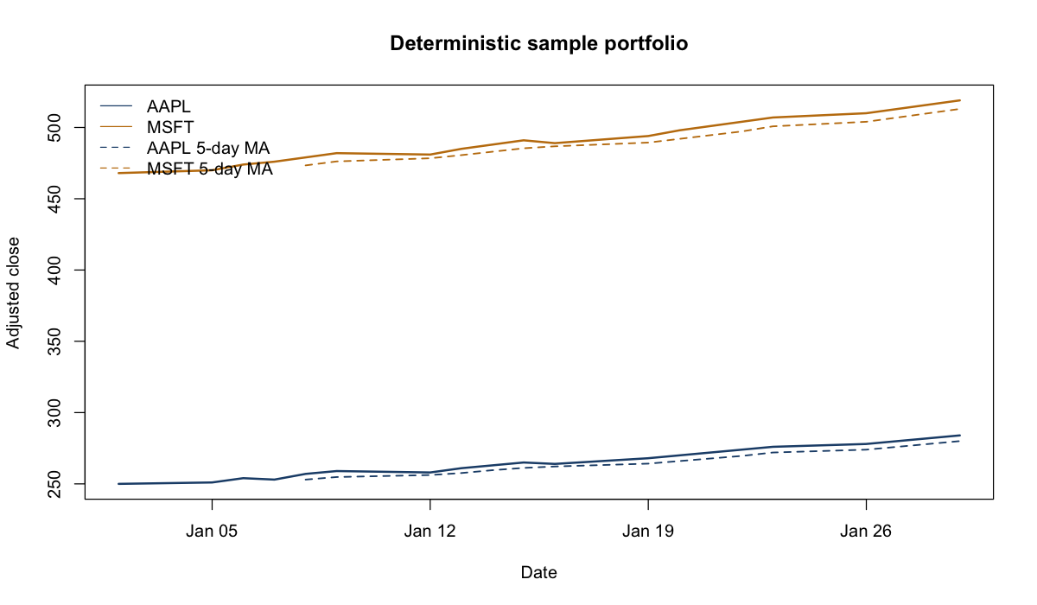
Figure 1. Genuine local R visualization generated by R/display_visualization.R from the deterministic sample data.

7. Reproducibility and limitations
The included test suite is intentionally built with base R assertions and local CSVs. It checks symbol order, row counts, representative summary values, moving-average availability, mode behavior, and positive standard deviation. The fresh passing test transcript is retained under work/runtime/test_analysis_output.txt; no internet connection is needed for this deterministic path.
A live Yahoo run is environment-dependent: it needs internet access, quantmod, zoo, and an available provider response. The report distinguishes the verified local R evidence from the remaining setup-history evidence and does not include invented screenshots.

8. Student completion checklist
Action | Where to record / verify
Create or confirm GitHub account | Completed in the signed-in account; repository evidence retained.
Create TechnicalAnalysis repository | Completed: https://github.com/sunny-khurana-26/TechnicalAnalysis
Install R and RStudio | Local computer; add screenshots.
Install quantmod, TTR, zoo | R/RStudio console; add screenshot.
Run tests and visualization | Completed locally; transcripts and PNG embedded; files retained under work/runtime and report-assets/.
Upload assignment files | Completed in the public TechnicalAnalysis repository; verify folder placement.
Insert real repository URL | Completed on this cover page and in README.md.
See STUDENT_ACTIONS.md for the same actions in an editable handoff format.

References from the assignment brief
Git installation: https://github.com/git-guides/install-git
Git setup: https://docs.github.com/en/get-started/quickstart/set-up-git
R / RStudio reference: https://cran.rstudio.com/
R package manual: https://cran.rstudio.com/doc/manuals/r-release/R-admin.html#Installing-packages
Stock-data presentation reference: https://finance.yahoo.com/
Report prepared from the local assignment PDF and the accompanying requirements checklist. No AI declaration is added because the source PDF does not state one as a requirement.

